CS285 HW1
Experiment 1
Hopper
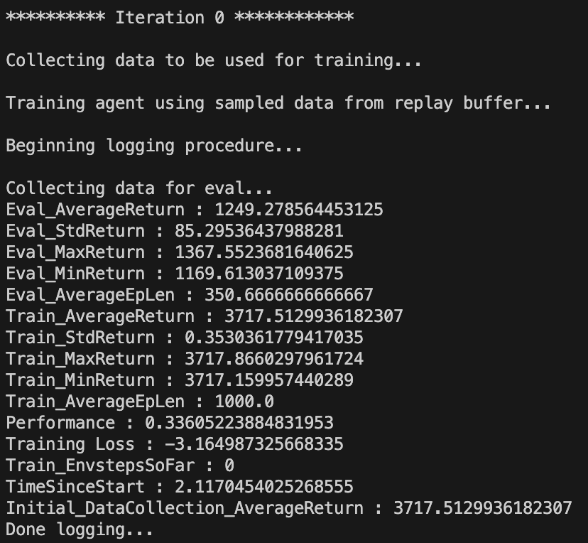
python cs285/scripts/run_hw1.py \
--expert_policy_file cs285/policies/experts/Hopper.pkl \
--env_name Hopper-v4 --exp_name bc_hopper --n_iter 1 \
--expert_data cs285/expert_data/expert_data_Hopper-v4.pkl \
--video_log_freq -1
- Performance: Eval_AverageReturn/Train_AverageReturn = 0.33
- Analysis:
Walk2d
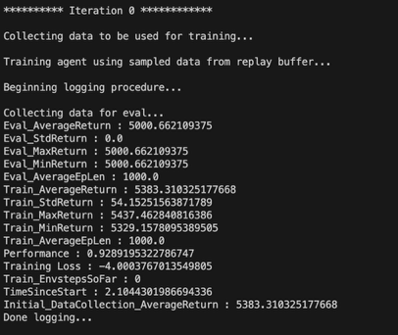
python cs285/scripts/run_hw1.py \
--expert_policy_file cs285/policies/experts/Walker2d.pkl \
--env_name Walker2d --exp_name bc_ant --n_iter 1 \
--expert_data cs285/expert_data/expert_data_Walker2d-v4.pkl \
--video_log_freq -1

- Performance 0.93
- Analysis: It’s result from 1iteration so I cannot believe this result fully. I’ll increase the iteration of eval_batch_size 1000 to 5000
After increase batch size
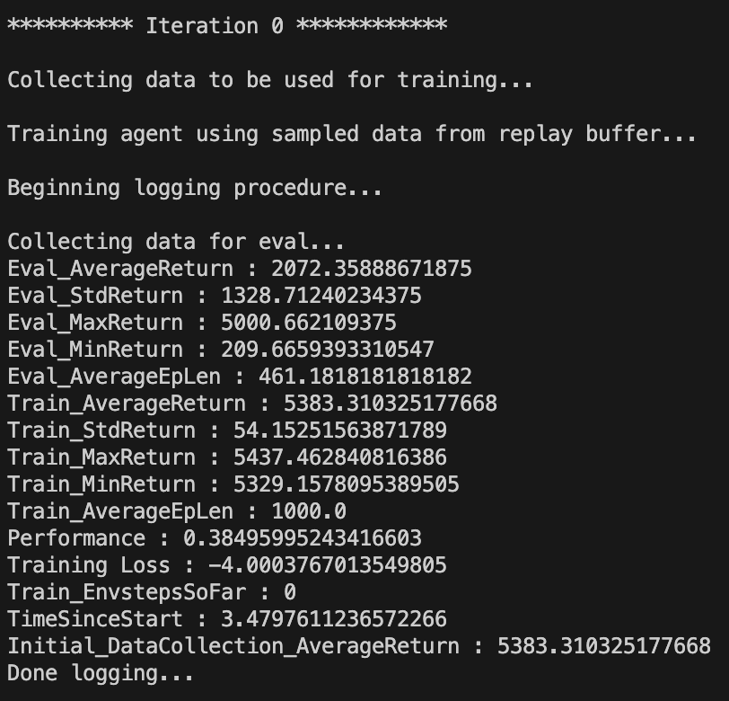
python cs285/scripts/run_hw1.py \
--expert_policy_file cs285/policies/experts/Walker2d.pkl \
--env_name Walker2d --exp_name bc_ant --n_iter 1 \
--expert_data cs285/expert_data/expert_data_Walker2d-v4.pkl \
--eval_batch_size 5000 \
--video_log_freq -1

- Performance 0.38
- Analysis: When I set a eval batch size as 1000 It selects 1 rollout. So it’s too dependent on luck. But in this case, after I increase eval batch size to 5000. It selects around 10 rollouts (5000/461 = 11, (Eval_AverageEpLen)). So this case’s performance is more trustable

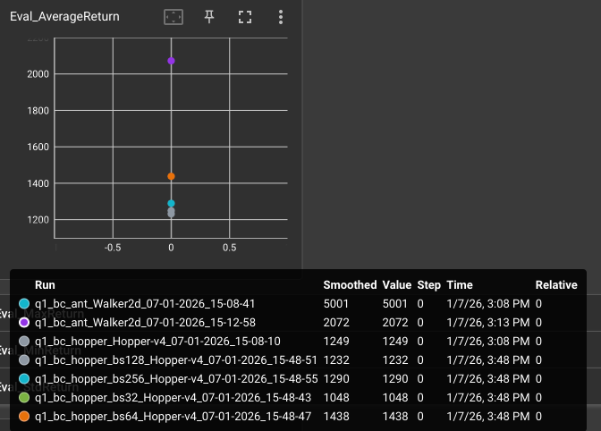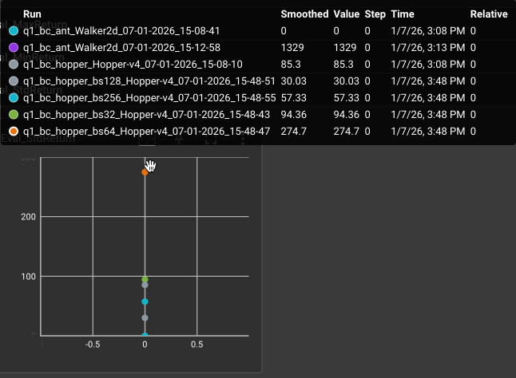
for b in 32 64 128 256; do
python cs285/scripts/run_hw1.py \
--expert_policy_file cs285/policies/experts/Hopper.pkl \
--env_name Hopper-v4 --exp_name bc_hopper_bs${b} --n_iter 1 \
--expert_data cs285/expert_data/expert_data_Hopper-v4.pkl \
--train_batch_size $b \
--video_log_freq -1
Done
- Analysis
  - If the mini batch size is increase which selected from each steps, the gradient estimation is more stable.
  - In Hopper-v4, small instabilities in the learned policy can cause the agent to fall early, leading to large variation in episode returns. This explains why the evaluation standard deviation (Eval_StdReturn) is relatively large for some settings (e.g., batch size 64), even when the average return is high
DAgger
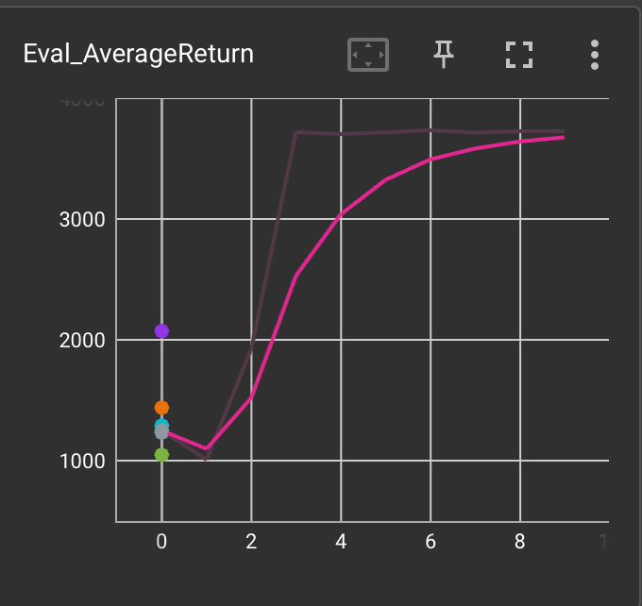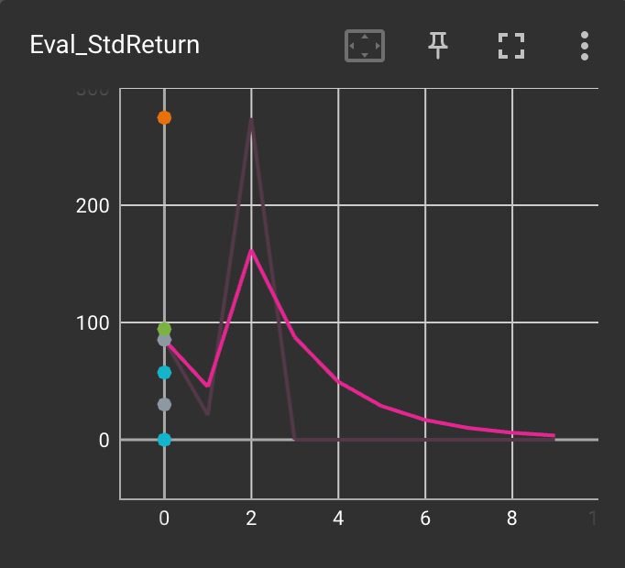
- Analysis: Eval_averageReturn is consistently increasing with iteration, it means the policy updated to get the higher cumulated reward. Also at eh eval_StdReturn, the graph tends to decrease, it means policy is stable and low variance!
Increase eval_batch_size
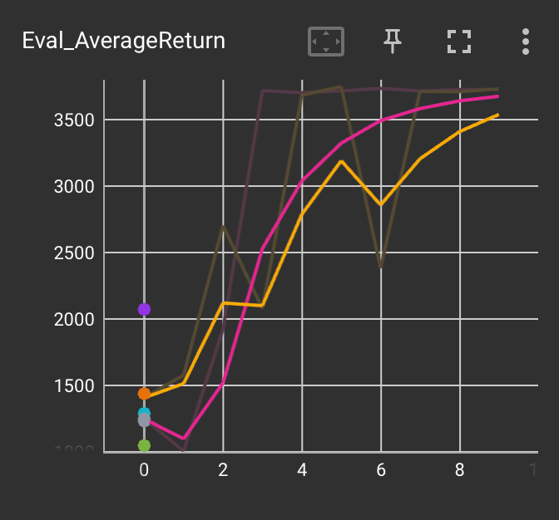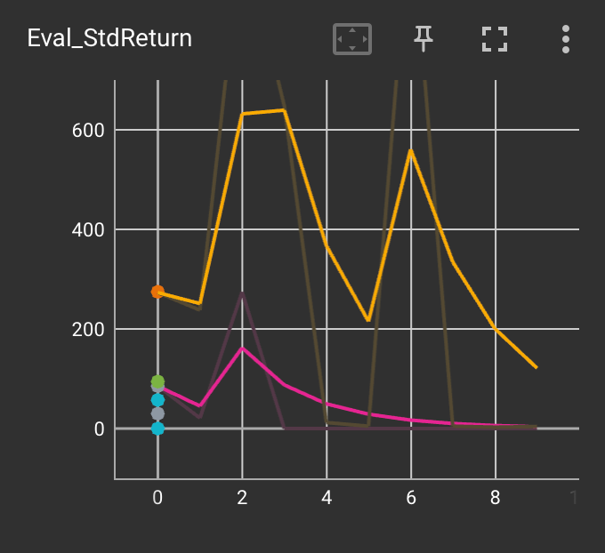
- Analysis
  - Some reason make the performance lower
    - We add too much states which our policy make, so the data became more difficult
    - Eval batch size is increased, so the luck of performance is weaker than original

